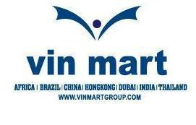
Dar es Salaam, being a gateway to Africa plays a vital role in global transportation, clearing and forwarding and is a main hub of emerging commerce. The sea port of the city is well connected with other ports all over the world. Dar Sea Port serves not only Tanzania but also many neighboring countries which are land locked or do not have a commercial harbor or port.
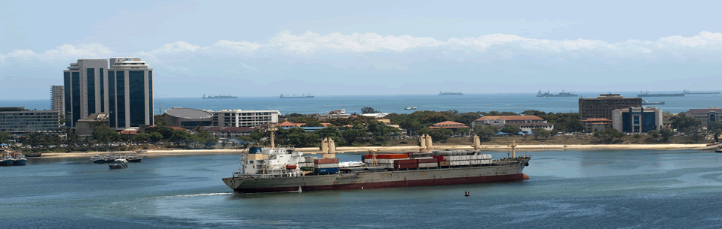

Vin Mart Limited, a well known name in CLEARING & FORWARDING based in this commercial hub of East Africa is a company registered in mainland of Tanzania in April 1997. Vin Mart provides its services to its esteemed customers in and around Tanzania with acute promptness since its inception; and is accepted by them as a global logistic house which can be relied on to solve their logistic problems in Africa. It is just because of this reason Vin Mart is a favorite and trusted name among its clientele scattered in Malawi, Zambia and D R Congo.

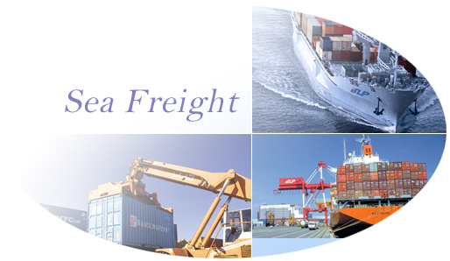

Vin Mart offers special “combo package” of clearing and forwarding which relieves our customers from the hassle and worries of their valued goods in transit especially to the land locked neighboring countries. Our clientele ranges from mining, heavy equipment dealers, manufacturers etc to traders in countries like Malawi, Zambia and D R Congo. Value added services coupled with competitive price and prompt services attract many new clients to Vin Mart year after year.

The group having a global presence through its overseas branches in countries like Canada, Brazil, UK, Germany, D R Congo, Angola, Mozambique, South Africa, Dubai, India and China, Vin Mart also serves as an important link between the group’s import and export activities. Our well equipped office in Dar es Salaam with latest communication equipments and efficient and dedicated work force make sure that both our export and import goods in transit are well tracked every day and assure safety of the consignment we handle. With the knowledge and experience of over 60 clearing and forwarding staff working for Vin Mart, we keep striving towards our goal “to save your time by investing ours”
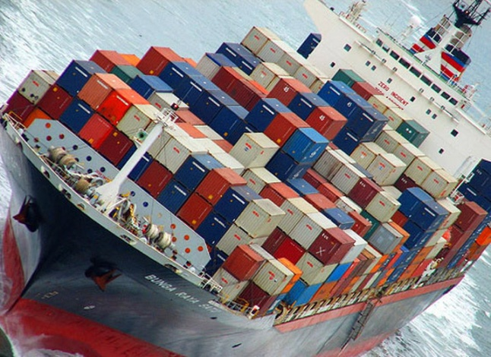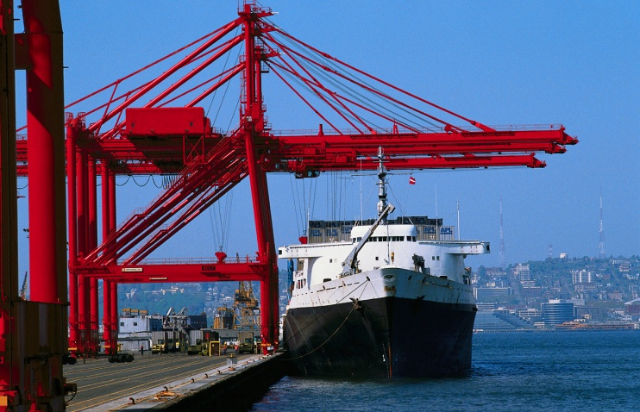
Our Customised Services:
Vin Mart, with our main objective to take our clients to the ease and comfort frontiers of modern freight forwarding, custom clearance and logistics, our mission is complete client satisfaction. We see ourselves as a logistics company engaged in clearing and forwarding of international standards, arranging multi modal and inter modal transport, integrated logistics services, supply chain management and third party logistics. Our services include;
- Negotiation of ocean/air freight & inland haulage charges.
- Import and Export clearance
- Packing/re-packing, palletizing, marking of cargo for shipment.
- Insurance at lower rates.
- Economical and efficient handling.
- Ware-housing and transportation.
- Arrangements to pick up the consignments from origin and deliver to port of destination.

